JILL B. SMART

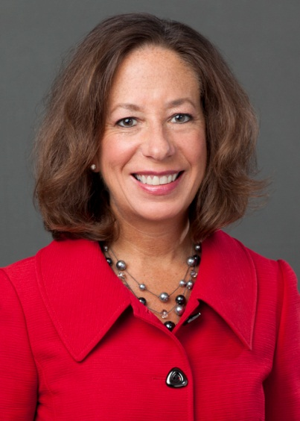
After spending over 33 years at Accenture, Jill retired from the organization and is currently the President of the National Academy of Human Resources (NAHR), a Director at EPAM Systems, a Director at AlixPartners, a Director at HireRight, and a member of the Cerity Partners Advisory Board.

The National Academy of Human Resources is the organization where individuals and institutions of distinction in human resources are recognized for professional achievement by election as a "Fellow of the NAHR". In addition, the NAHR furthers the HR profession through numerous educational activities as well as research initiatives.

Based in Philadelphia, EPAM Systems, Inc. (NYSE: EPAM), a leading global product development and platform engineering services company, is focused on delivering results through best-in-class software engineering, combined with innovative strategy, consulting and design capabilities. With 25 years of experience in the information technology industry, EPAM’s 28,000 people serve their customers in over 25 countries across North America, Europe, Asia and Australia.

AlixPartners is a results-driven global management consulting firm that specializes in helping businesses successfully address their most complex and critical challenges. Clients include companies, corporate boards, law firms, investment banks, private equity firms and others. Founded in 1981, AlixPartners is headquartered in New York, and has offices in more than 20 cities around the world. Jill is a representative of strategic investment partner La Caisse de dépôt et placement du Québec (“CDPQ”), which handles the Canadian province’s $308 billion in pension plan and insurance program investments.

HireRight is the market-leading provider of on-demand employment background checks and screening. With clients in over 200 countries and territories, nearly fifty percent of the Fortune 100 use HireRight’s services. Based in Irvine, California HireRight has offices around the globe.

Based in New York, Cerity Partners is an SEC-registered investment advisor offering independent, comprehensive financial advice to individuals and their families, businesses and their employees, and non-profit organizations. Cerity Partners has been recognized by The Financial Times, Forbes, Worth, Investment News, and Private Asset Management as one of the leading and/or fastest growing independent wealth managers in the United States.

Jill retired from Accenture in 2014. At the time of her retirement, she had been Accenture's Chief Human Resources Officer for 10 years, with overall responsibility for the full employee lifecycle of all Accenture people globally—including resource planning, recruitment, on-boarding, training and development, staffing and deployment, performance management, engagement and retention, succession planning and transitions. She was also a member of Accenture's Global Management Committee.

Under Jill’s leadership, Accenture’s global headcount grew from 100,000 to 289,000, with offices and operations in more than 200 cities in 56 countries. Jill delivered for Accenture during periods of explosive growth, often hiring more than 5,000 people per month, and also successfully navigated a major economic contraction. In addition, Jill oversaw a comprehensive shift in Accenture’s talent strategy to focus on emerging markets.

To better support Accenture’s dramatic growth and evolution, Jill transformed the HR function—improving HR’s agility at changing with the business, boosting the efficiency of HR’s processes, and enhancing the career experience of HR practitioners—while also reducing cost.

Before being appointed chief human resources officer in September 2004, Jill was Managing Director of HR delivery, which entailed overall responsibility for human resources operations and people development. From 2000 until 2003, she was head of the company's People Enablement business practice, which included training and knowledge management.

Prior to assuming HR management roles, Jill spent most of her career at Accenture leading business integration consulting work for clients in the financial services, federal and state government, transportation and health services industries. Her client experience focused primarily on integrating strategy, technology business processes, functional applications and human performance components to lead clients through major change initiatives.

From 2017 through 2019, Jill was an Advisory Board member of JB Training Solutions, a Chicago-based learning and development company that develops employees throughout their entire life cycle - from entering the workforce all the way to succeeding as an executive, through training programs that build stronger leaders, powerful communicators, and exceptional employees in a multigenerational workforce.

From 2015 until its sale in 2018 Jill was on the board of Alexander Mann Solutions (AMS). Based in London, AMS helps companies and individuals fulfill their potential through talent acquisition and management, providing solutions across the entire talent life cycle—from strategic workforce planning and employer branding, to assessment and selection, to on-boarding and employee engagement.

Jill is a Fellow and Director of the National Academy of Human Resources, a Fellow of the Human Resources Policy Institute (HRPI), a member of the Peer Roundtable for CHROs (PRT), a member of the G100 Talent Consortium Advisory Board, and has been a Director of the HR Policy Association (HRPA). Jill has been an active member of HR50 and the RBL Institute.

Jill is a member of the Board of Trustees of the University of Illinois, is on the board and has been a Director and Officer of the Alumni Association, is on the College of Business Dean’s Business Council (and has served as the Council’s Chair) and serves on the board of the University’s Chicago Athletic Association Board. She has served as an adjunct faculty member, and has been on the Advisory Council of Illinois Business Consulting (IBC).

Jill is a Trustee of Chicago's Goodman Theatre, and is active in The Chicago Network. She has also been on the Board of Fenwick High School.

Jill received an MBA from the University of Chicago and a bachelor's degree in business administration from the University of Illinois.

