# MICHAEL A. PEEL

**Title:** Managing Partner, Peel Global Advisory, LLC

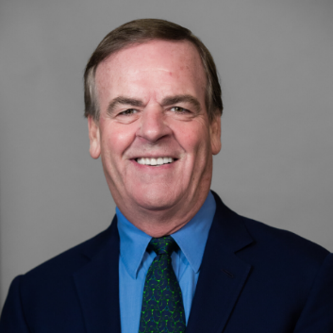

Michael A. Peel is the managing partner of Peel Global Advisory, LLC, a consulting firm that provides human capital and board consulting to corporations, private equity firms, cultural organizations, and academic institutions. Both in business and academia, Peel is known for his transformation and change management expertise, and for having built award-winning human resources organizations at iconic institutions like Yale University, General Mills and PepsiCo.   
   
Peel recently retired from Yale University, where he worked directly for two successive presidents, serving as the vice president of Human Resources and Administration for nearly nine years. Peel is recognized for having achieved the longest period of labor peace in the turbulent union relations history of the university and for transforming Yale’s talent formation and succession planning processes. His efforts more than doubled the diversity of the university’s 4,000 leaders.  
   
Prior to joining Yale, Peel was the chief human resources officer of General Mills for more than 17 years, during which the company was recognized with more than 200 workplace honors, including being selected regularly by *Fortune Magazine’s* “100 Best Companies to Work For” and “10 Most Admired Companies in the World for Developing Leaders.” He also held various senior human resources roles at PepsiCo during his fourteen year tenure, including serving as CHRO for two of the company's largest and most successful operating divisions—Pepsi-Cola Bottling Group and PepsiCo International Foods.    
   
In addition to serving as the chair on DeVry University’s Board of Trustees, Peel serves on the boards of the Sleep Number Corporation, Pier 1 Imports, HireRight, and Boon.com.   He is a senior advisor to the private equity firms Palm Ventures and Angeles Equity Investors, senior advisor to ghSMART & Associates, and senior advisor to Gympass.  He was previously the vice chair for the Human Resources Policy Association, the chair of the Walker Art Center board, chair of the Leadership in Education (LEAD) organization, and secretary-treasurer of the National Academy of Human Resources.    
   
Peel earned a bachelor of science in business administration from James Madison University and an MBA from Columbia University Graduate School of Business. In 2003, Peel was honored as a Fellow of the National Academy of Human Resources, the profession’s highest honor.  He was also awarded an honorary Masters of Science degree from Yale University.