Michael L. Davis

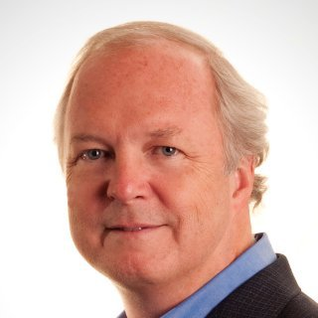

Mike currently works selectively as a senior human resources advisor and educator.

Mike retired from General Mills in 2014. At that time he was Executive Vice President, Human Resources. He had been the company’s chief human resources officer since 2008. Mike joined General Mills in 1996 as the VP, Compensation & Benefits. Subsequently, he also served as VP, HR, Corporate and VP, HR, US Retail. He was named a senior vice president in 2008 and an executive vice president in 2013.

Prior to joining General Mills, Mike worked at Towers Perrin from 1981 to 1996 in various compensation consulting roles. During these years he worked in the firm’s Chicago, New York and Minneapolis offices. He was named both a Principal (partner) and a Vice President (senior partner) while at the firm, and consulted mainly with large corporations and boards. When Mike left Towers Perrin, he was the firm’s worldwide consulting practice leader for executive compensation.

Prior to working at Towers Perrin, Mike worked from 1977 to 1981 in the Information Systems department at Continental Illinois National Bank & Trust in Chicago.

Mike has served in board leadership roles for a number of human resources industry associations; these organizations include the National Business Group on Health, the Human Resources Policy Association, the Employee Benefits Research Institute, WorldatWork, and the National Committee for Quality Assurance (in health care). Mike has also served on the boards of the Saint Paul Chamber Orchestra, the Minnesota Historical Society, and The Minneapolis Club.

Mike was named a Fellow in the National Academy of Human Resources in 2012. In 2013, he was named the Distinguished Human Resources Executive by the National Academy of Management.

Since 2006, Mike has been an adjunct professor at the Carlson School of Management at the University of Minnesota. He teaches graduate-level classes in compensation & benefits, executive compensation, and leadership development.

Mike is a frequent panelist, speaker and media expert on compensation, benefits and broader HR matters. He has been quoted over the years in many of the nation’s leading business journals and newspapers.

Mike earned two bachelor’s degrees in 1977 from Purdue University in Industrial Management and Computer Science. In 1981, Mike earned an MBA from the Graduate School of Business at the University of Chicago. Mike is also a Certified Public Accountant.

Mike and his wife Celia reside in Minneapolis and Washington, DC.

