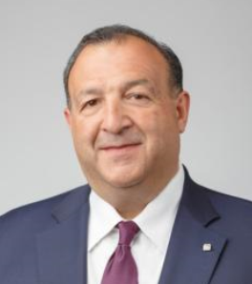
Michael D’Ambrose
Michael D’Ambrose is senior vice president and chief human resources officer for Archer Daniels Midland Company, and a member of the company’s Executive Council. In this capacity, he oversees all global human resources, payroll, aviation and security operations as well as corporate services.
Prior to joining ADM, D’Ambrose served as executive vice president, Human Resources for First Data, one of the world’s largest providers of transaction processing services for retail companies. He has held the senior human resources roles at Citibank, Citigroup, Toys ’R‘ Us Inc. and Travelers Mortgage Services as well as key roles at Ingersoll-Rand Corporation. Earlier in his career, D’Ambrose also founded Shadow Broadcasting Services before serving as chief operating officer for Westwood One, Inc.
D’Ambrose is a fellow of the National Academy of Human Resources, a distinction that—when he was inducted in 2016—had only been conferred upon 163 individuals since 1992. He also spearheaded ADM’s leadership role in creating the Agriculture Diversity & Inclusion Consortium, a cross-functional council representing industry, academia, NGOs and legislative bodies that is working to grow the pipeline of diverse talent for the U.S. agriculture industry. He is a member of the board of directors for Jobs for America’s Graduates (JAG), where he serves as chair of the Resource Development Committee. He serves on the board of directors for The Cornell Center for Advanced Human Resource Studies (CAHRS); is a member of the HR Policy Association; is a board member for the Center for Executive Succession at the Darla Moore School of Business at the University of South Carolina; serves on the Board of the Health Transformation Alliance, a consortium of major employers working to improve the way corporations provide health care benefits; and is a member of the CHRO Global Leadership Board, a collaboration between the world’s most distinguished and trusted Chief Human Resources Officers.
D’Ambrose is a graduate of Cornell University’s School of Industrial and Labor Relations in Ithaca, New York.

