Kenneth Hutchinson

President Emeritus, AAU-Human Resource Institute; VP Emeritus
University of Missouri System
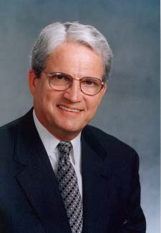
Ken Hutchinson currently serves as president emeritus of the AAU-Human Resource Institute, a group comprised of chief human resource officers of AAU universities. The group was founded in 2009. Previously, he served as the chief human resource officer of the University of Missouri System for 30 years. He served, with the president of the University, the campus chancellors, vice presidents, and general counsel, as one of eleven General Officers of the University of Missouri. He was the primary contact with the university’s governing board on human resource initiatives, programs and policies and held membership on the Compensation and Human Resource Committee of the Board of Curators.
Among his professional and board activities, Hutchinson has served as national president of the College and University Professional Association for Human Resources; and president of the CUPA-HR Foundation. He served on the Board of Trustees of the Washington-based Employee Benefits Research Institute (EBRI); Board of Directors of the Capitol Regional Medical Center; Board of Directors of the University of Missouri Health Board; Board of Directors of the National Academy of Human Resources; Board of Trustees of the National Academy of Human Resources Foundation. Hutchinson served on a five-member board committee, chaired by the Chairman of Emerson Electric, Charles F. Knight, which provided a comprehensive assessment of the governance structure of the University of Missouri. Hutchinson has served as speaker for national seminars on organizational performance, individual performance and productivity, labor relations, benefits and general management.
Hutchinson was inducted as a Fellow in the National Academy of Human Resources in 2000 and was elected to the NAHR Board in 2004. Hutchinson is the 2007 recipient of EBRI’s Lillywhite Award, given annually in recognition of distinguished careers in the field of employee benefits. He is also the recipient of CUPA-HR’s Donald E. Dickason Award, the highest individual award given by CUPA-HR for contributions to the association. The University of Missouri Board of Curators bestowed on him the title Vice President Emeritus, University of Missouri, effective January 1, 2008.
Hutchinson earned a B.S. in Business Administration and a B.S. in Psychology from Truman State University and a Masters in Educational Leadership and Policy Analysis from the University of Missouri. Hutchinson currently owns Hutchinson Consulting LLC and provides limited consulting to select clients on executive performance, benefits and talent management.

