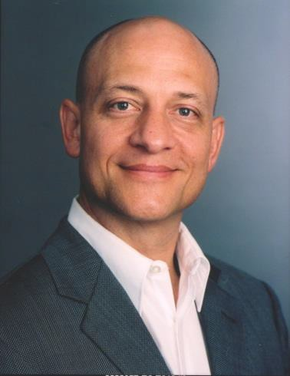
John W. Boudreau, Ph.D., Professor and Research Director at the University of Southern California’s Marshall School of Business and Center for Effective Organizations, is recognized worldwide for breakthrough research on the bridge between superior human capital, talent and sustainable competitive advantage. Dr. Boudreau consults and conducts executive development with companies worldwide that seek to maximize their employees’ effectiveness by discovering the specific strategic bottom-line impact of superior people and human capital strategies. http://ceo.usc.edu/research_scientist/boudreau.html

Dr. Boudreau has more than 200 publications including books such as Lead the Work, with Ravin Jesuthasan and David Creelman (Wiley, 2015), Retooling HR: Using Proven Business Tools to Make Better Decisions about Talent, (Harvard Business, 2010) and Beyond HR: The New Science of Human Capital, with Peter M. Ramstad (Harvard Business, 2007), Short Introduction to Strategic Human Resources with Wayne Cascio (Cambridge University Press, 2012), Transformative HR, with Ravin Jesuthasan (John Wiley and Sons, 2011), Global
Trends in Human Resource Management: A Twenty-Year Analysis, with Edward Lawler (Stanford University Press, 2015), and Investing in People, with Wayne F. Cascio, now in its second edition (Pearson, 2011.

Dr. Boudreau’s large-scale research studies and focused field research addresses the future of the global HR profession, HR measurement and analytics, decision-based HR, executive mobility, HR information systems and organizational staffing and development. His scholarly research is published in Management Science, Academy of Management Executive, Journal of Applied Psychology, Personnel Psychology, Asia-Pacific Human Resource Management, Human Resource Management, Journal of Vocational Behavior, Human Relations, Industrial Relations, and Journal of Human Resources Costing and Accounting. Features on his work have appeared in Harvard Business Review, The Wall Street Journal, Fortune, Fast Company and Business Week, among others.

He is the recipient of the 2013 Michael Losey award from the Society for Human Resource Management (SHRM) for excellence in research that has enhanced the human resource profession. His research received the Academy of Management’s Organizational Behavior New Concept and Human Resource Scholarly Contribution awards. He received the 2009 Chairman’s Award from the International Association for Human Resources Information Management (IHRIM) for lifetime achievement in human resource information management. He is a Fellow of the National Academy of Human Resources, and the Society for Industrial and Organizational Psychology and American Psychological Association.

Professor Boudreau was the first Visiting Director of Sun Microsystems’ unique Research and Development Laboratory for Human Capital. He co-authored a best-selling textbook on human resource management that reached its eight edition including Chinese, Czech, Spanish and other translations.

The recipient of the General Mills Award for teaching innovations at Cornell University, Dr. Boudreau founded the Central Europe Human Resource Education Initiative, connecting American HR professionals and academic researchers with faculty and students in the Czech and Slovak Republics. A strong proponent of corporate/academic partnerships, Dr. Boudreau helped to establish and then directed the Center for Advanced Human Resource Studies (CAHRS), at Cornell University, where he was a professor for over 20 years, before his current position as Research Director for the Center for Effective Organizations, at the University of Southern California.

Dr. Boudreau is a strategic advisor to a wide range of organizations, including early-stage companies, global corporations, government and military agencies, and non-profit organizations. He is a Foundation Trustee of the National Academy of Human Resources. He has served as a member of the board of advisors the Human Resource Planning Society and WorldatWork. He chaired the Advisory Board of the California Strategic HR Partnership, a silicon-valley HR executive consortium, and served as an advisor to the Saratoga Institute, a global source of human capital benchmarking and performance measures. He has been elected to the executive committees of the Human Resources Division of the Academy of Management and the Society for Industrial and Organizational Psychology.

Dr. Boudreau holds an undergraduate degree in business from New Mexico State University, and a Masters degree in Management and Ph.D. in industrial relations from Purdue University’s Krannert School of Management.

