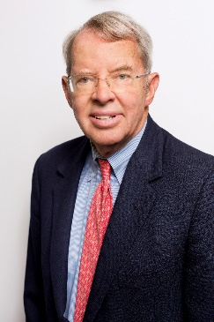
FRED K. FOULKES
Director, Human Resources Policy Institute
Professor of Management and Organizations
Boston University Questrom School of Business

Professor Foulkes received M.B.A. and D.B.A. degrees from Harvard Business School and an A.B., magna cum laude, Phi Beta Kappa, from Princeton University.
His principal publications include: Creating More Meaningful Work (The American Management Association); Casebook on Church and Society (with Keith Bridston, Ann D. Meyers and Louis Weeks, Abington Press); Personnel Policies in Large Nonunion Companies (Prentice-Hall); Human Resources Management: Cases and Text (with E.R. Livernash, Prentice-Hall); Employee Benefits Handbook (editor and contributing author Warren, Gorham & Lamont); Strategic Human Resources Management: A Guide for Effective Practice (Prentice-Hall), Human Resources Management: Readings (Prentice-Hall) and Executive Compensation: A Strategic Guide for the 1990s (Harvard Business School Press). Professor Foulkes has also written numerous articles, including five published in the Harvard Business Review, and has developed over 160 case studies.
Professor Foulkes is the founder and director of the Human Resources Policy Institute, a partnership between Questrom School of Business faculty and over 45 chief HR officers of many of the largest companies in the United States. Members include: Colgate, CVS Health, Fidelity Investments, HP, IBM, P&G and Raytheon.
Recipient of the Employment Management Association Award and the Five Star Achievement Award from the Northeast Human Resources Association, Professor Foulkes was named a Fellow of the National Academy of Human Resources (NAHR), the human resources profession’s highest honor for outstanding achievement.
A former director of Bright Horizons Family Solutions and Panera Bread where he was on the audit committee and chair of the compensation committee, and Wheelock College, he is a director of Operation ABLE and a member of the NAHR Foundation Board. A former board member of the Human Resources Planning Society and both the Society for Human Resources Management (SHRM) and the SHRM Foundation, he is a senior advisor to the Northeast Human Resources Association (NEHRA), a SHRM chapter, and leader of its Senior Executive HR Forum. He is also the chair of the Nutrition Roundtable at the Harvard T.H. Chan School of Public Health and a member of the Management Program Advisory Board of the Harvard University Extension School.

He and his wife live in Belmont, MA, and are the parents of two sons, one a student at Amherst College and the other working at a start up in San Francisco.

