Eva Sage-Gavin
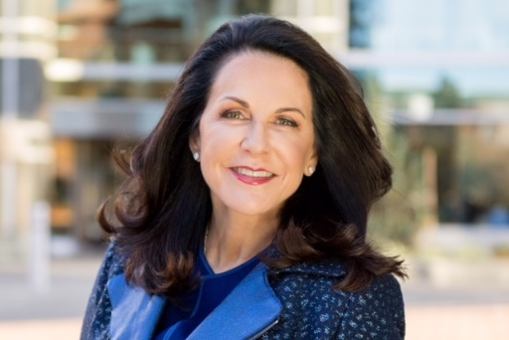
Eva Sage-Gavin is senior managing director of Accenture’s Global Talent and Organization consulting practice. She leads the team that helps Accenture’s clients harness digital technologies and evolve their workforces to innovate, unlock new sources of value and “lead in the new.” She also plays a pivotal role in shaping the practice’s market strategy, including offerings and investments. Sage-Gavin is honored to be recognized as a Top 100 HR Tech Influencer by HR Executive for shaping the world of HR Technology and helping to determine its future.
Sage-Gavin has more than three decades of broad experience in Fortune 500 global consumer, technology and retail corporations. She has served in C-suite roles and as a Chief HR Officer at Gap, Inc., PepsiCo, Disney Consumer Products, Sun Microsystems and Xerox.
A former senior advisor at Boston Consulting Group (BCG), Sage-Gavin contributed to BCG's CEO Advisory practice, directly coaching CEOs. She also served as a senior advisor to G100 companies, supporting CEOs, board directors and chief human resource officers.
The first female member of multiple public technology company boards, Sage-Gavin served as Co-chair of Women Corporate Directors, Bay Area chapter.
Sage-Gavin is executive in residence at the Cornell University School of Industrial and Labor Relations, is the former chair of the Center for Advanced Human Resource Studies and is a recipient of the William B. Groat award for lifetime achievement in the field of human resources. She is a guest lecturer at Stanford University’s Graduate School of Business and at the Santa Clara University Leavey School of Business. Sage-Gavin serves on the advisory board of Aspen Institute's UpSkill America and is a Fellow of the National Academy of Human Resources.
Eva holds a bachelor's degree in industrial and labor relations from Cornell University.

