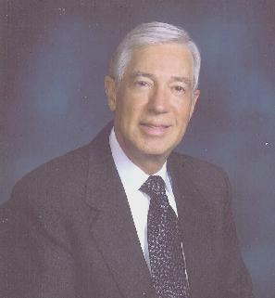
Richard W. Hallock

Business Advisor/Consultant/Investor

Executive Vice President (Retired) Occidental Petroleum Corporation

Following successful careers at IBM and Occidental Petroleum, Richard Hallock now provides client companies, individuals and organizations valued expertise in the areas of Private Company Management, Investments, Executive Compensation, Human Resources, Financial Management, Real Estate and International Management.
Mr. Hallock began his career with IBM as a Human Resources professional at a large manufacturing facility and progressed through various HR management positions at plants, development laboratories, divisions and IBM’s corporate headquarters. He was named Director of Human Resource Programs for Europe, Middle East and Africa based in Paris, France in 1985 and, upon returning to the US in 1988 assumed worldwide responsibility for employee relations, compensation, benefits and executive compensation. In 1994 he was recruited to become Executive Vice President of Human Resources for Occidental Petroleum Corporation, reporting to the Chairman and CEO. In this capacity, until his retirement he was the corporate officer responsible for human resources, real estate, security, flight operations and administration.
Mr. Hallock has served on the Boards of five private companies, helping each successfully manage substantial business, financial and inter-generational ownership transitions. He has also served as President of an investment holding company and two real estate companies, and has served as the Chair of Executive Compensation and Audit Committees. Additionally he has had responsibility for multi- billion dollar pension, savings and retirement programs both in the United States and Europe. Currently Mr. Hallock is an active investor, with significant management advisory and ownership interests in a portfolio of private companies focused on technology, software, bio-medical and internet opportunities.
Mr. Hallock is a member of several not-for-profit boards, including the National Academy of Human Resources where he has been named a Fellow. He chairs three charitable foundations, and has been associated with the Boy Scouts’ Los Angeles organization as past President and currently as a Board and Executive Committee member. He also serves on the Investment Committee of two early stage private equity funds.
Mr. Hallock and his wife Anne live in Los Angeles, California. They have two children and four grandchildren. In addition to his professional, non-profit and family interests, he enjoys golf and cycling.

