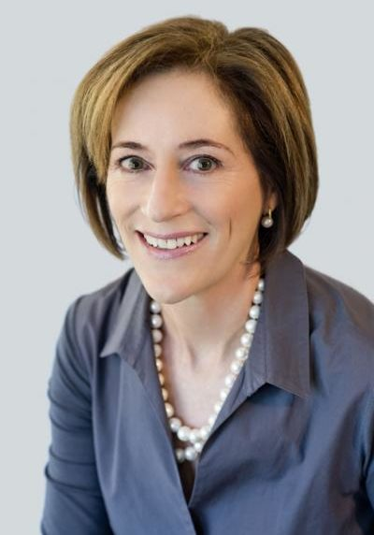

Diane Gherson, CHRO, IBM

Diane was named an officer of IBM and CHRO in 2013. Diane is responsible for the people strategy, leadership, skills, careers, engagement, employee services, labor cost, diversity and inclusion of the 360,000 person workforce covering 72 countries.

During her tenure as CHRO, as IBM has dramatically shifted its business portfolio, Diane has redesigned all aspects of the company’s people agenda and management systems to shape a culture of continuous learning, innovation and agility. At the same time, she has digitally transformed the HR function, incorporating AI and automation across all offerings, resulting in more than $100 million in net benefits in 2017. Diane has championed the company’s global adoption of design thinking and agile methods at scale, as an example, driving a company-wide, co-created overhaul of performance management.

Diane has been an external advocate for social issues affecting employees, such as DACA, transgender inclusion, and addressing bias in AI. Under Diane’s leadership in stewarding diversity and inclusion, IBM received the prestigious 2018 Catalyst Award for advancing women in business. The company was also named a Forbes’ Top 10 World’s Best Employer in 2017.

With a U.S. patent in the field of predictive analytics, Diane is a leading voice on the topic of reinventing the profession of HR to create consumer-grade experiences for employees, predictive advice for business leaders, and improved productivity for the business. Diane was recently interviewed on Fox Business News and CNN on automation and future of work and her leadership to transform IBM and HR has been profiled in Forbes, Fortune and Harvard Business Review.

In 2018, Diane was named HR Executive of the Year by HR Executive, and was elected as Fellow of the National Academy of Human Resources (NAHR), the highest honor granted in the human resource profession. She serves on the board of directors of the HR Policy Association and the American Health Policy Institute.
Diane joined IBM in 2002 from consulting firm Willis Towers Watson where she led the global pay and performance management practice. Diane earned a Bachelor of Arts with honors from Trinity College, University of Toronto, and a master’s degree in Industrial and Labor Relations from Cornell University. She is all but dissertated in the PhD program at the Sloan School of Management.

