David A. Rodriguez
Executive Vice President and Global Chief Human Resources Officer

David A. Rodriguez assumed the role of executive vice president and global chief human resources officer for Marriott International in 2006. Dr. Rodriguez was appointed a corporate officer in 2000, and in 2004, in his role as Marriott’s global officer of diversity and inclusion, to the board of directors’ Committee for Excellence that focuses on advancing employee wellbeing and inclusion in the company.
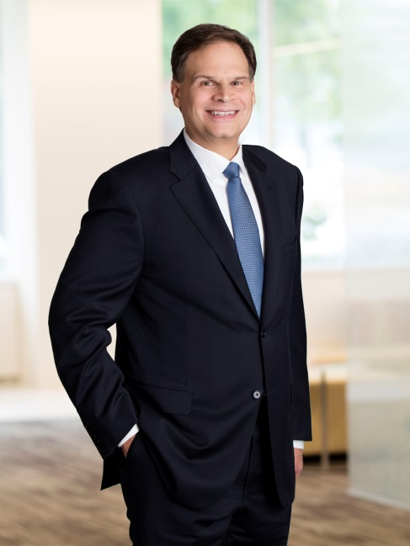
Dr. Rodriguez joined Marriott International and assumed the role of senior vice president – human resources in 1998. In 2003, he was appointed an executive vice president with responsibility for corporate centers of expertise as well as for the U.S. human resources function. Prior to joining Marriott International, Dr. Rodriguez held various human resources leadership positions at Citibank.

Dr. Rodriguez graduated from New York University with a bachelor of arts degree and a doctorate in industrial/organizational psychology. He is chairman of the American Health Policy Institute, a vice chair of the Human Resources Policy Association and serves on the board of the Health Transformation Alliance. Dr. Rodriguez was inducted as a Fellow of the National Academy of Human Resources in 2014. He was recognized as the HR Executive of the Year by Human Resource Executive magazine in 2019.
http://news.marriott.com/p/david-a-rodriguez/

