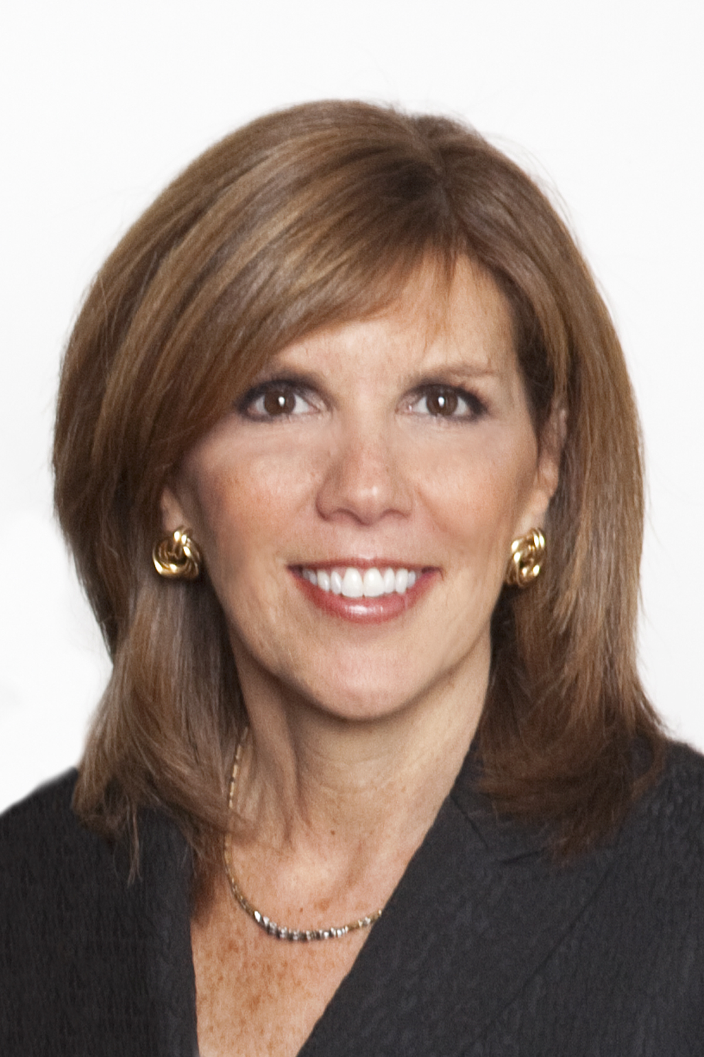
Carole Watkins
Executive Biography
Board Member | Delta Dental Plan of Ohio and it’s parent Renaissance Health Service Corporation (Current)
CHRO | Cardinal Health, Inc. | (Retired 2016)

Ms. Watkins currently serves as an independent director on the board of Delta Dental of Ohio and is on the Executive and Nominating Committees. She also serves as a director on the board of Delta Dental of Kentucky and is on the Foundation Advisory Committee. In addition, Ms. Watkins serves as an independent director on the board of Renaissance Health Service Corporation and serves on the Audit/Finance and the Governance Committees.

As chief human resources officer (CHRO) of Cardinal Health, Ms. Watkins reported directly to the Chairman and CEO. She started with the company in 1996 and assumed the CHRO role in 2005 after progressing through several promotions, and taking on leadership positions in Human Resources and other high level corporate functions. Ms. Watkins also served on the Executive Committee and the Strategy and Innovation Council, both led by the CEO. During the time she was in the CHRO role, the company underwent several transformations, including two CEO transitions, two large divestitures, and numerous acquisitions.

As CHRO, Ms. Watkins had global and enterprise-wide leadership responsibility for all of HR, as well as Corporate Communications, Security, Real Estate, Facilities and Aviation. In addition, she played a vital role with the Board of Directors, serving as the management advisor to the HR and Compensation Committee, handling all executive compensation recommendations, attending all Cardinal Health Board meetings, and leading talent management and succession planning, including CEO succession. Cardinal Health is a highly acquisitive company, and the Board recognized that talent is critical to the success of any acquisition or other form of corporate growth. In due diligence Ms. Watkins was thus called upon by Cardinal’s management team and Board to evaluate both the talent and corporate culture, and then to assist the acquired company and its leaders as it was being assimilated into Cardinal’s culture and management structure. She also served on the Cardinal Health Foundation Board for many years, and as its Chair from 2001 to 2005. Prior to joining Cardinal Health, Ms. Watkins gained more than 20 years of Human Resources experience with other leading companies including The Limited, O. M. Scott & Sons and Huntington Banks.

In 2013, Ms Watkins received two significant honors. First, she was named a Woman of Achievement by the Central Ohio YWCA, an award recognizing women who have made extraordinary contributions to families, workplaces and communities. Second, she was inducted as a Fellow into the National Academy of Human Resources, the highest honor given to CHROs, recognizing her achievements and contributions to the profession. In addition, in 2015, Ms. Watkins received the Pillar Award as non-profit board executive of the year in Columbus, Ohio. And, in 2017 she received the HR Lifetime Achievement Award from Columbus CEO Magazine.

Ms Watkins is also very active in the community. She serves on the Global Board for the Serious Fun Children’s Network (camps for children with serious illness which was founded by Paul Newman), and just rolled off the board of Flying Horse Farms (one of the SFCH camps) where she served for 10 years including 3 years as Chair. She is also a Trustee for Franklin University, where she is Chair of the Human Resources Committee. In addition, she volunteers with the American Heart Association, primarily on the Central Ohio “Go Red for Women” campaign, having chaired the 2008 Central Ohio “Go Red for Women” campaign/luncheon. She also served on the Board of Action for Children for over ten years, including a stint as President from 2006 –2008, and on the Board of The Childhood League from 2010–2014.

Since retiring from Cardinal Health, Ms. Watkins is engaged in coaching new CHROs as well as Coaching Executives as they plan for retirement and succession. She has also remained active in a number of professional HR groups, serving among other things on the Board of the National Academy of Human Resources and on the Executive Committee of the Global Peer Roundtable (PRT) for CHROs.

Carole Watkins
caroleswatkins@gmail.com
614-571-8251 (cell)

