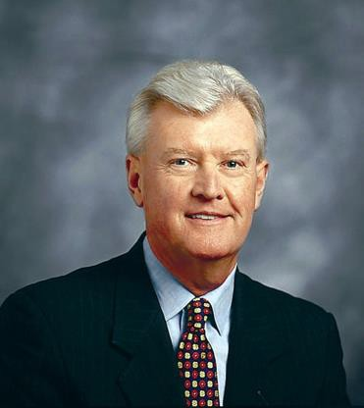
Bill Conaty

Bill Conaty spent 40 years with GE before retiring at the end of 2007. As senior vice president for Human Resources from 1993 to 2007, he has long been recognized as a world leader in his field. In 2008 he joined Clayton, Dubilier and Rice as an Advisory Partner.

A native of Binghamton, New York, he earned his bachelor’s degree from Bryant University in Rhode Island. After graduating from a three-year management program at GE and military service, he held management positions in a number of GE operations including Aerospace, Rail, and Aircraft Engines. In 1990, he was elected a company officer and became vice president for Human Resources at GE Aircraft Engines. Just three years later, he was selected by Jack Welch to the senior vice presidency of Corporate Human Resources with responsibility for over 320,000 employees worldwide. He served Welch for eight years and Jeff Immelt for six years before his retirement.

In great measure due to the management development and training programs Bill engineered, BusinessWeek declared that GE had “the most talent-rich management bench in the world.” A profile in the same magazine praised him for taking “a department that’s often treated as a support function” and turning it “into a high-level business partner.” Jack Welch, called him “spectacular,” explaining that “he has earned enormous trust at every level. The union guys respect him as much as the senior managers.” Jeff Immelt referred to him as the Company’s “first friend”. Bill retired after concluding his fifth successful round of National Labor negotiations with GE’s unions, and handing over the top HR job to a long-time GE HR colleague.

Bill served as a Trustee at Sacred Heart University for over a decade, and received an Honorary Doctorate degree in May 2010. He currently serves as Chair of the Board of Trustees at his alma mater, Bryant University. He also served on the Advisory Board of Cornell University’s Center for Advanced HR Studies, where his legacy continues with the GE endowment of the William J. Conaty Chair in Human Resources. In November 1996, he was inducted as a Fellow to the National Academy of Human Resources, elected Chairman in February 2001, and named Distinguished Fellow, the highest honor, in November 2007. Bill also served as Chairman of the HR Policy Association from 2001 to 2007. In 2011, he joined the Board of Directors at The Goodyear Tire & Rubber Company and the Board of Trustees of the Dartmouth- Hitchcock Hospital.

Bill is active on the speaking circuit as a world leader in HR and has been a featured guest on CNBC’s Squawk Box. He co-authored a book with Ram Charan titled “The Talent Masters … Why Smart Leaders Put People Before Numbers” which was published by Random House in November 2010.

