William S. Allen
linkedin.com/in/williamsallen • 646-629-0620 • bill@allenadvisorsllc.com

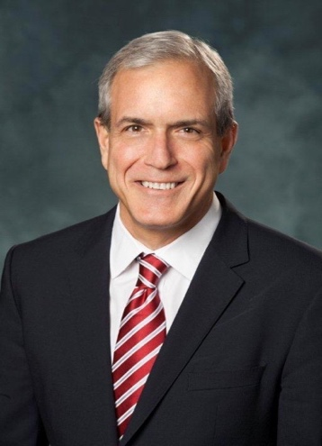
Bill Allen is the President of Allen Advisors LLC and partners with clients in private equity and large-cap companies, including Sun Capital Partners, Logistics Capital & Strategy, LLC, and Ahold Delhaize, with a passionate focus on delivering sustainable value for clients.

A Senior Executive with more than 20 years of experience as the Chief Human Resources Officer of three listed companies, Bill spent nearly one-third of his career living outside the U.S. His deep experience began in PepsiCo’s Frito Lay division and flourished during his time as CHRO at the A.P. Moller-Maersk Group. He also was Chief Human Resources Officer for Macy’s and Chief Human Resources Officer at Atlas Air Worldwide Holdings, Inc. He began his career with RCA Corporation.

Bill is a Fellow of the National Academy of Human Resources and sits on several boards. He attended the Human Resources Executive Program at the University of Michigan and holds a Master of Science in Industrial and Labor Relations from the University of North Texas and a Bachelor of Science in Business from Auburn University. He is a frequent guest lecturer at universities, including the business schools at Auburn, Copenhagen, Harvard, North Carolina, South Carolina and Penn.

Bill and his wife, Beth, have two adult children and live in Newry, ME, where they enjoy family, friends and the great outdoors.

