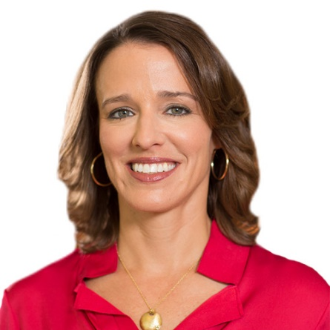

Ashley Goldsmith
Chief People Officer
Ashley Goldsmith is chief people officer at Workday and has global responsibility for human resources, global impact, workplace facilities, and the Workday Foundation.
Prior to joining Workday, Ashley served as CHRO and executive vice president at Polycom. Preceding Polycom, she was senior vice president of human resources, corporate communications, and environmental health and safety for the Tissue Diagnostics Division at F. Hoffmann-La Roche. Ashley has also previously served as CHRO at Ventana Medical Systems and as divisional vice president of human resources at The Home Depot.
Ashley holds a Master of Business Administration degree from the Kellogg School of Management at Northwestern University, a master’s degree in human resource development from Georgia State University, and a bachelor’s degree in psychology from Vanderbilt University.

